Include the extraction of data using R, from columns such as Device. This is show the Extra effort we made to turn JSON columns into flat File.

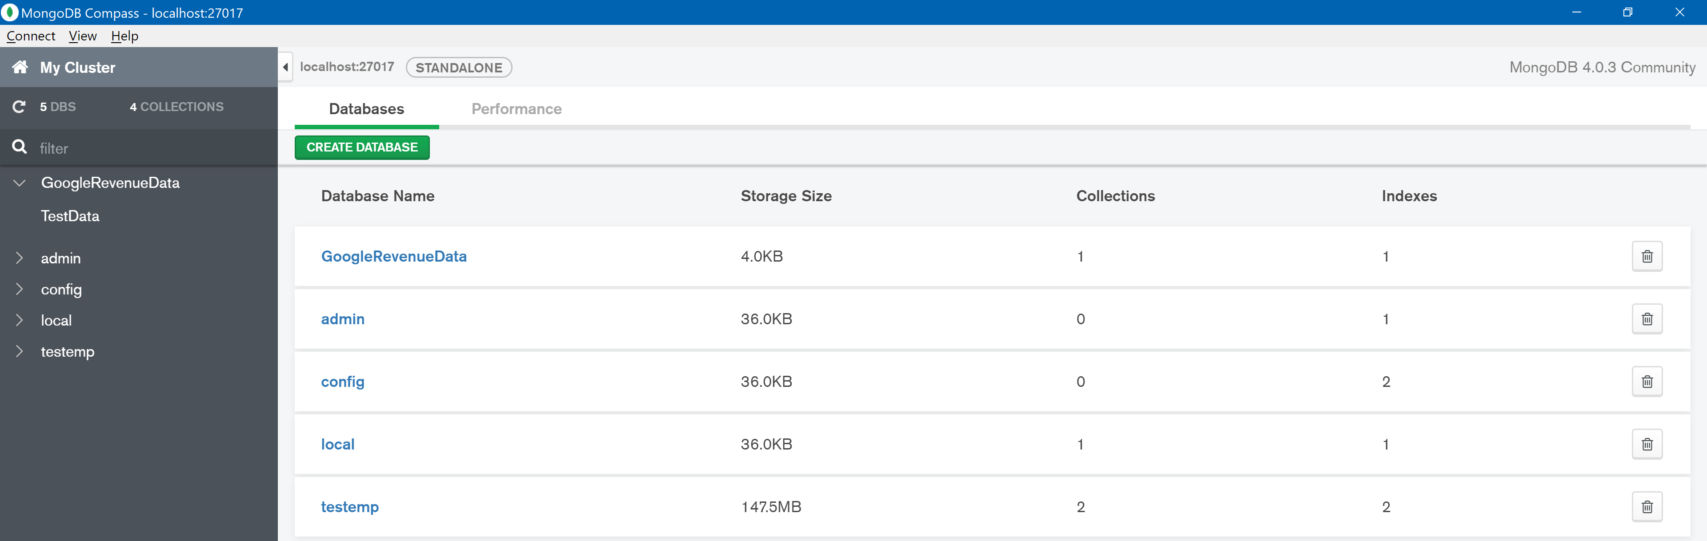

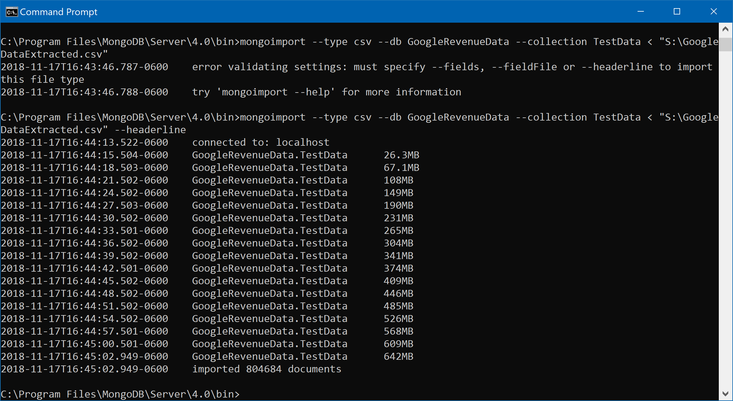

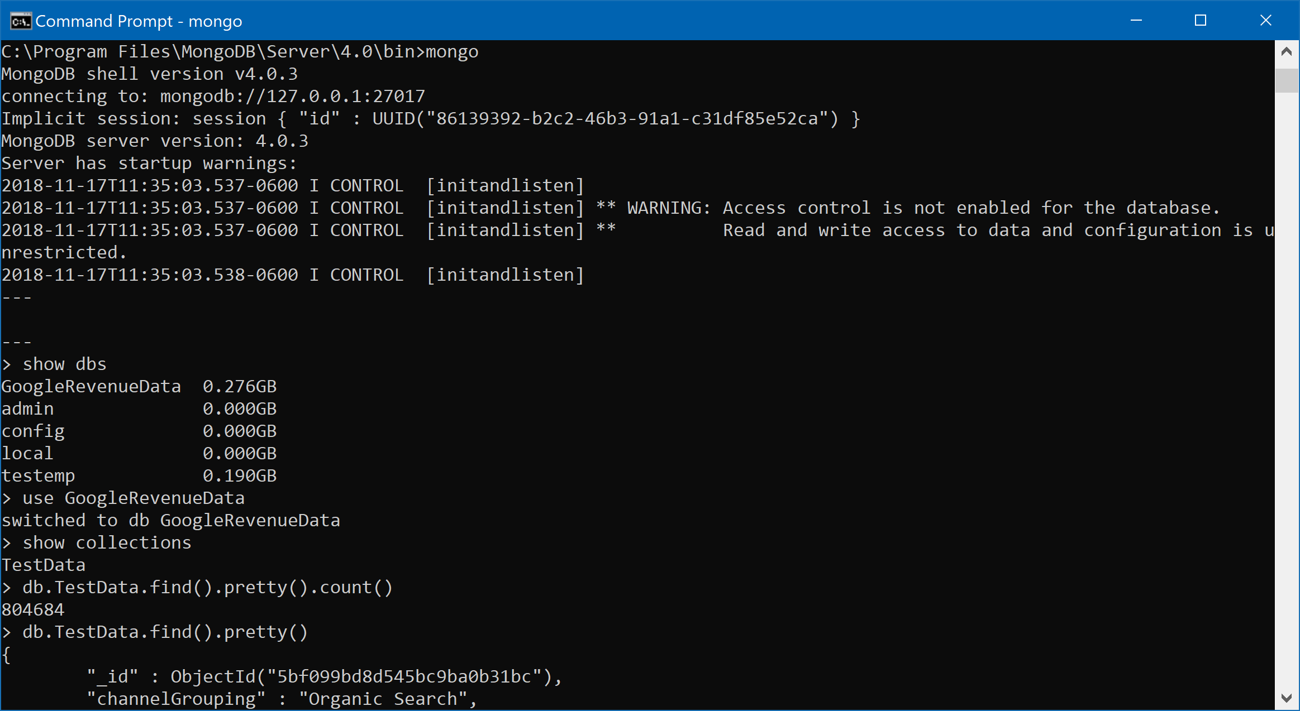

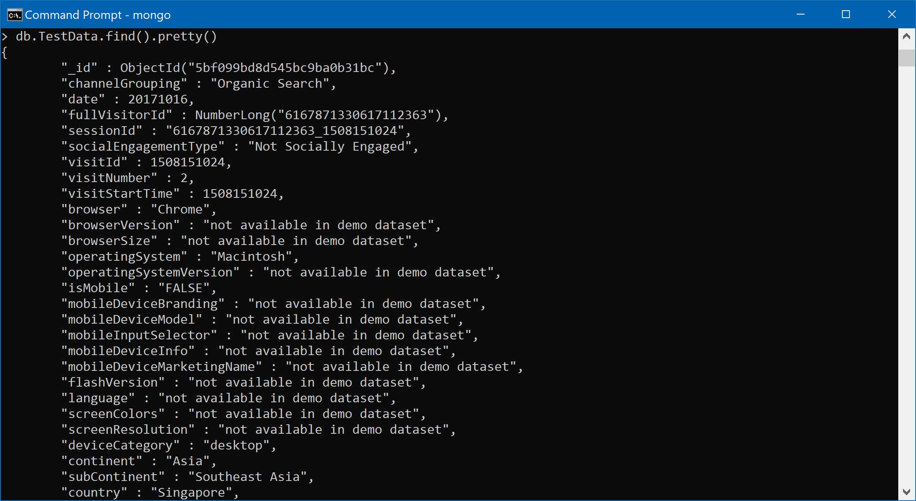

1. **Which user had the maximum number of visits and when?**

No SQL:

db.TestData.aggregate([

{$group: {_id: {fullVisitorId: "$fullVisitorId", date:"$date"}, total:{$sum:"$visits"}}},

{$sort: {total: -1}},

{$limit:1}

],

{allowDiskUse:true})

Screenshot:

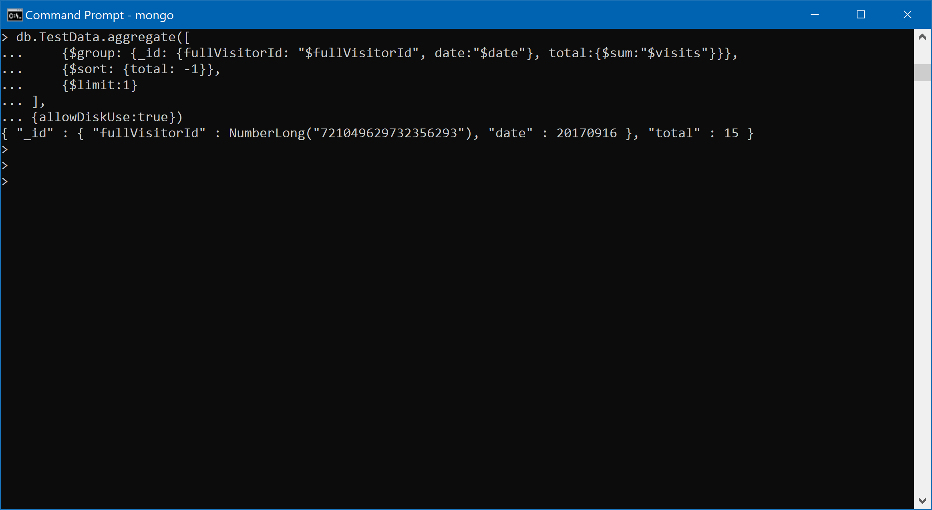

### Question

**2. Is a Windows user more likely to visit the store than Macintosh user?**

NO SQL Query:

db.TestData.aggregate([

{$match:{operatingSystem: {$in: ["Windows","iOS"]}}},

{$group:{_id: "$operatingSystem",CountOS:{$sum:1}}},

{$sort: {CountOS: -1}}

])

Screenshot:

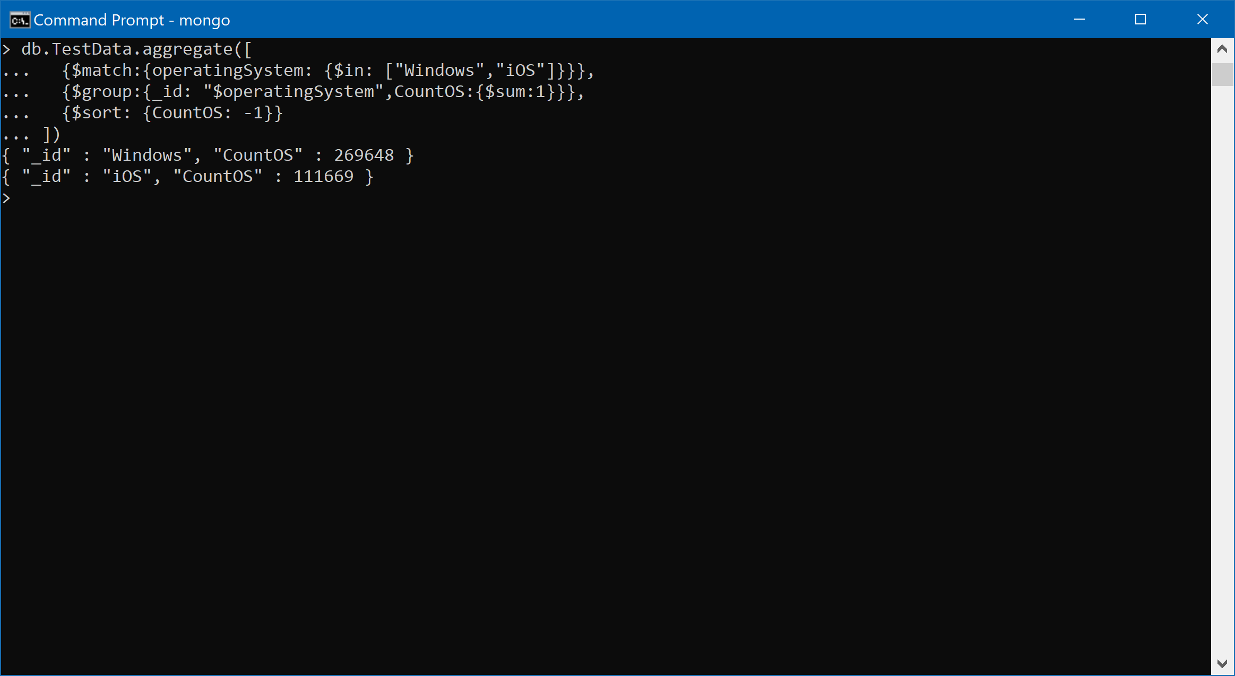

### Question

2. Is a blackberry user less likely to visit the store than iOS user?

No SQL Query:

db.TestData.aggregate([

{$match:{operatingSystem: {$in: ["BlackBerry","iOS"]}}},

{$group:{_id: "$operatingSystem",CountOS:{$sum:1}}},

{$sort: {CountOS: -1}}

])

Screenshot:

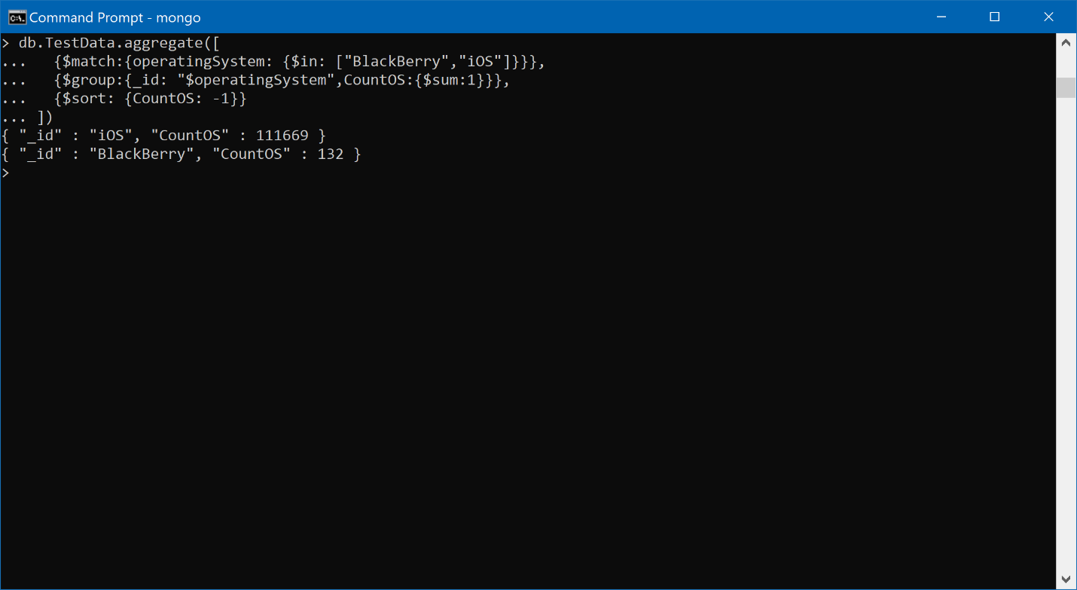

3. Which date had the least and most number of visitors with non-mobile devices?

No SQL Query:

db.TestData.aggregate([

{$match:{isMobile:"FALSE"}},

{$group:{_id:{date:"$date",isMobile:"$isMobile"},Count:{$sum:1}}},

{$sort: {Count: 1}},

{$limit:1}

],

{allowDiskUse:true})

db.TestData.aggregate([

{$match:{isMobile:"FALSE"}},

{$group:{_id:{date:"$date",isMobile:"$isMobile"},Count:{$sum:1}}},

{$sort: {Count: -1}},

{$limit:1}

],

{allowDiskUse:true})

Screenshot:

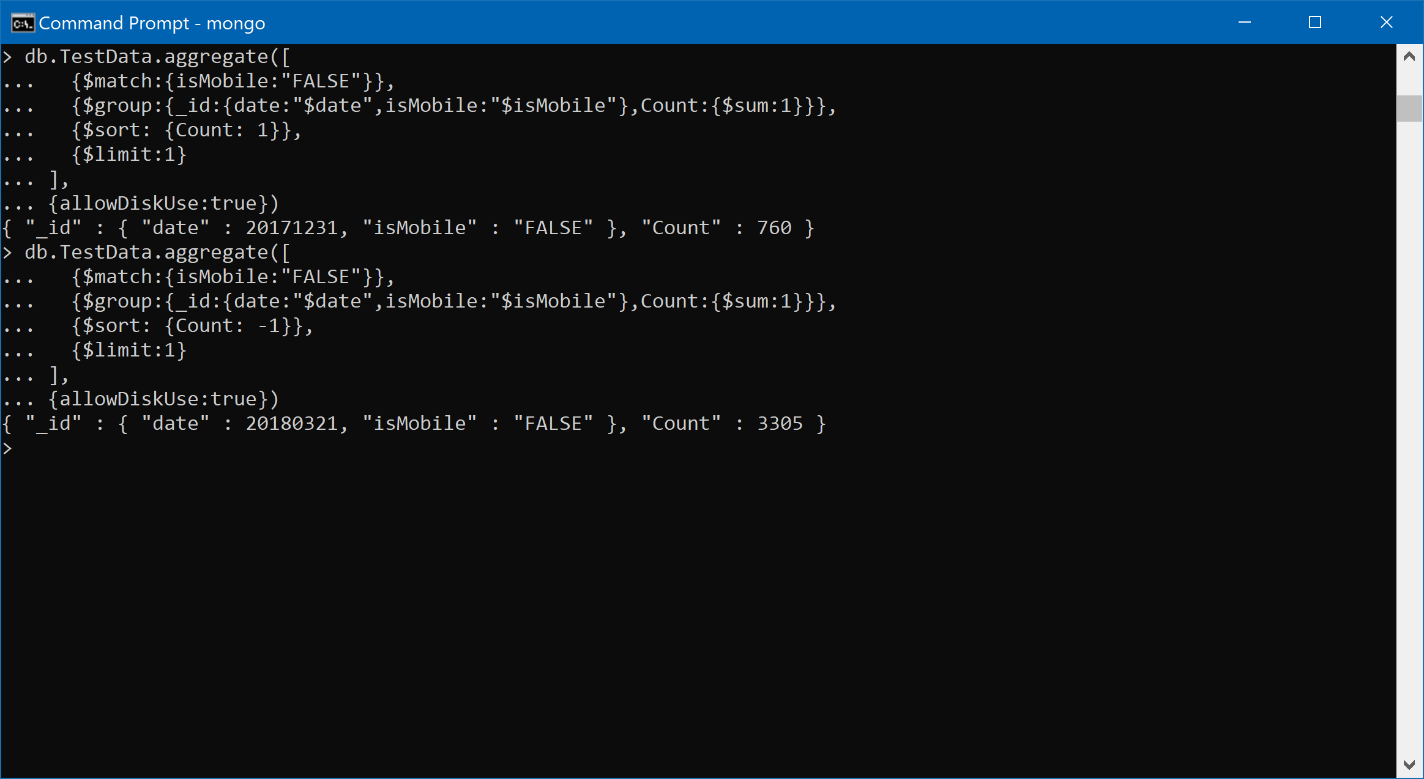

4. Were mobile devices users more socially engaged than non-mobile device users?

No SQL Query:

db.TestData.aggregate([

{$group:{_id:{socialEngagementType:"$socialEngagementType"},Count:{$sum:1}}},

{$sort: {Count: -1}}

])

db.TestData.aggregate([

{$group:{_id:{ismobile:"$isMobile",socialEngagementType:"$socialEngagementType"},Count:{$sum:1}}},

{$sort: {Count: -1}}

])

Screenshot:

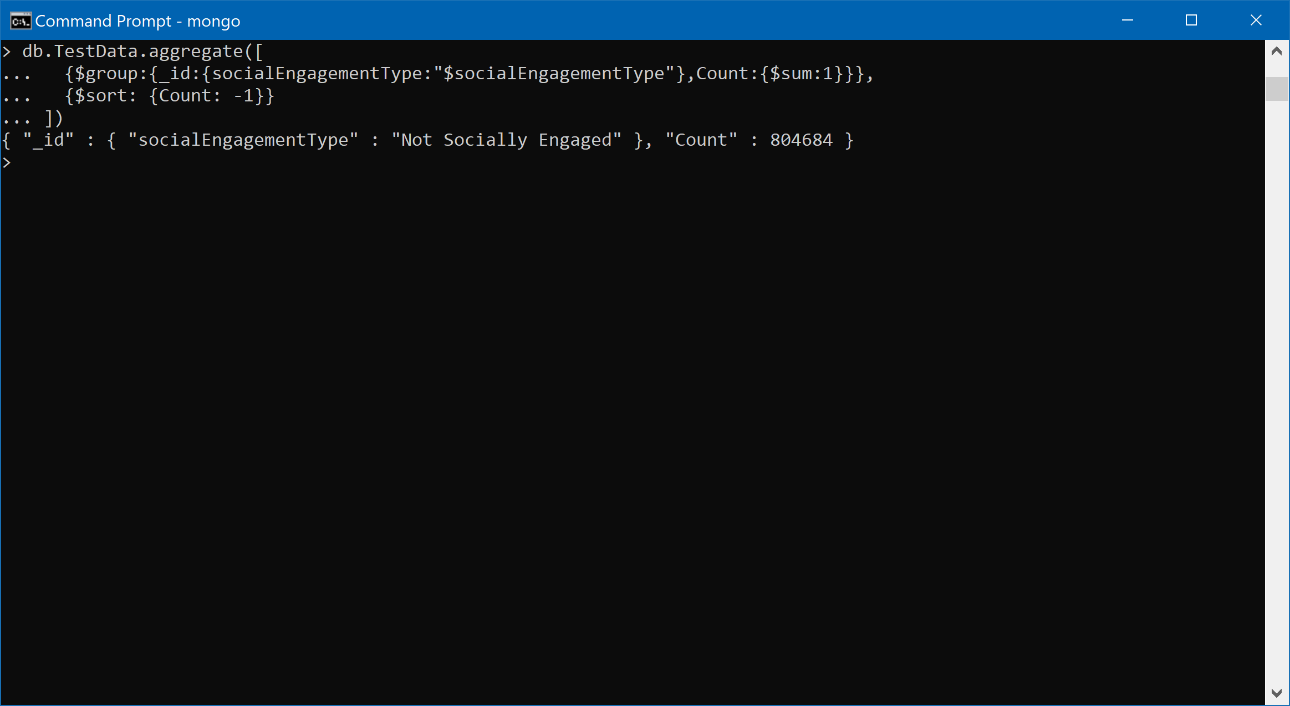

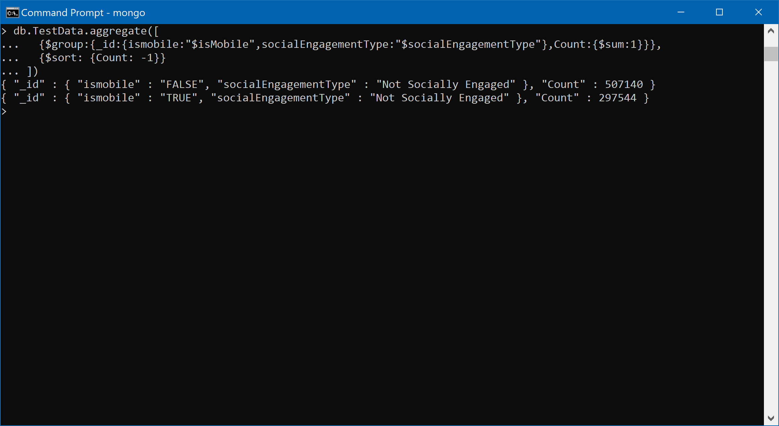

5. Provide a breakdown of store hits by region

No SQL Query:

db.TestData.aggregate([

{$match:{region:{$nin:["not available in demo dataset","(not set)"]}}},

{$group:{_id:{region:"$region"},hits:{$sum:"$hits"}}},

{$sort: {hits: -1}}

])

Screenshot:

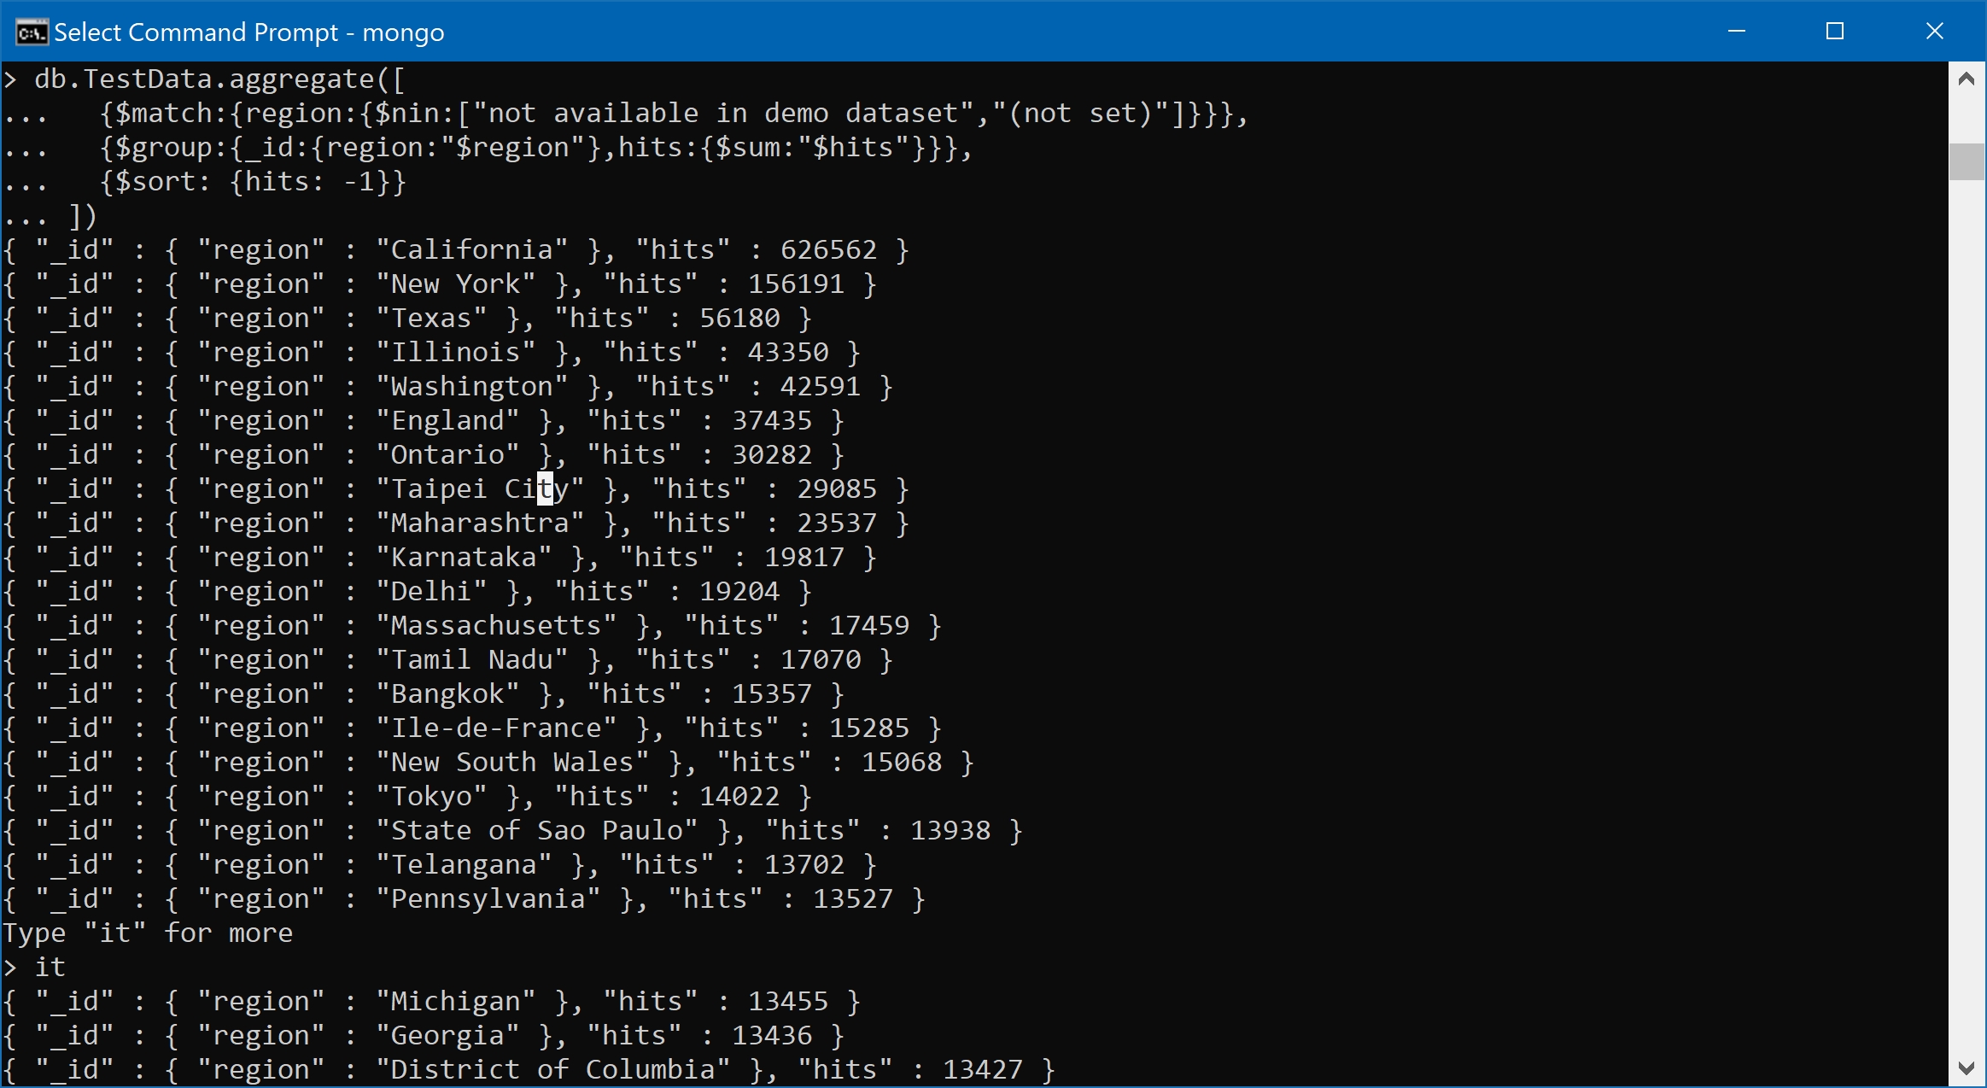

6. How many users used only Macintosh devices to visit the store?

No SQL Query:

db.TestData.aggregate([

{$match:{operatingSystem:"iOS"}},

{$group:{_id:{operatingSystem:"$operatingSystem"},Count:{$sum:1}}}

])

Screenshot:

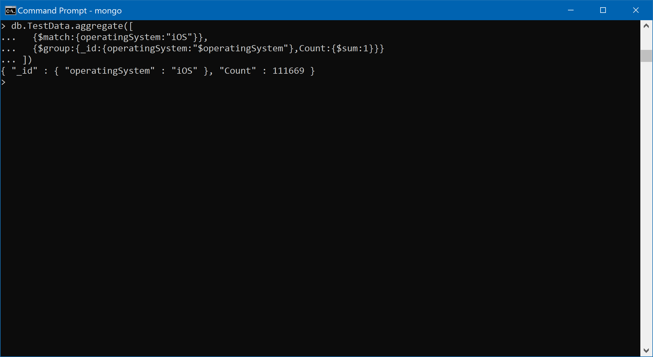

7. What was the average number of hits per unique visitor?

No SQL Query:

db.TestData.distinct("visitId").length

db.TestData.aggregate([

{$group:{_id:null,Count:{$sum:"$hits"}}}

])

Screenshot:

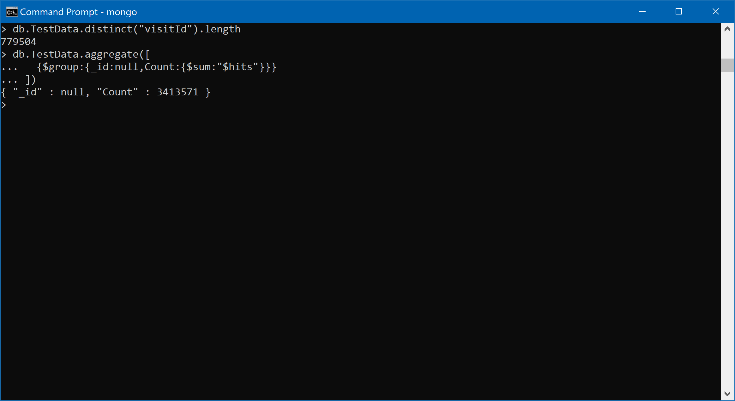

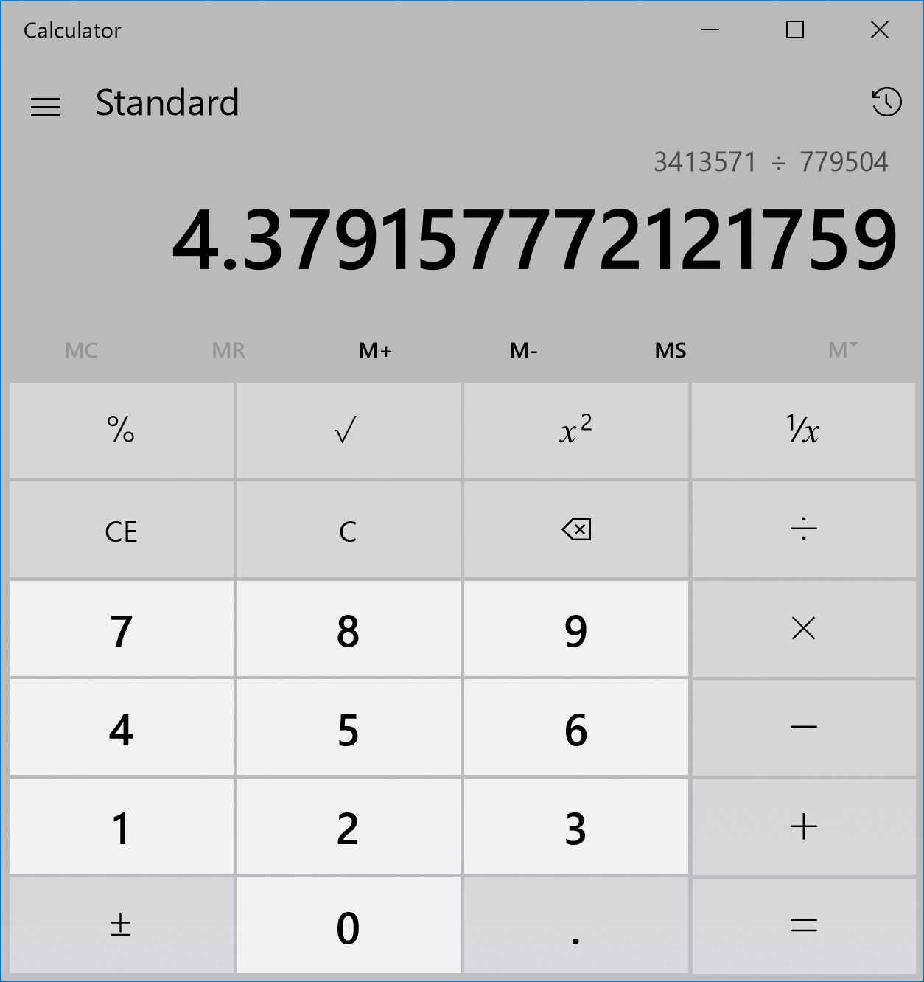

4.37 is the Average number of hits per unique customer

8. Visitors from which country visited the store the most?

No SQL Query:

db.TestData.aggregate([

{$group:{_id:"$country",Count:{$sum:1}}},

{$sort: {Count: -1}},

{$limit:1}

])

Screenshot:

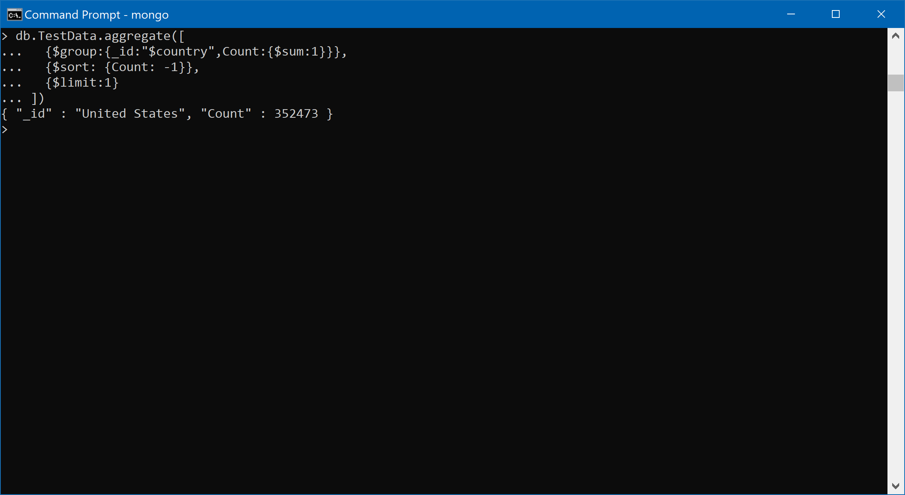

OLD Queries

3. Which date had the most number of iOS users from Belgium?

No SQL Query:

db.TestData.aggregate([

{$match: {$and: [{operatingSystem:"iOS"},{country:"Belgium"}]}},

{$group:{_id:{operatingSystem:"$operatingSystem",country:"$country",date:"$date"},Count:{$sum:1}}},

{$sort: {Count: -1}},

{$limit:1}

])

Screenshot:

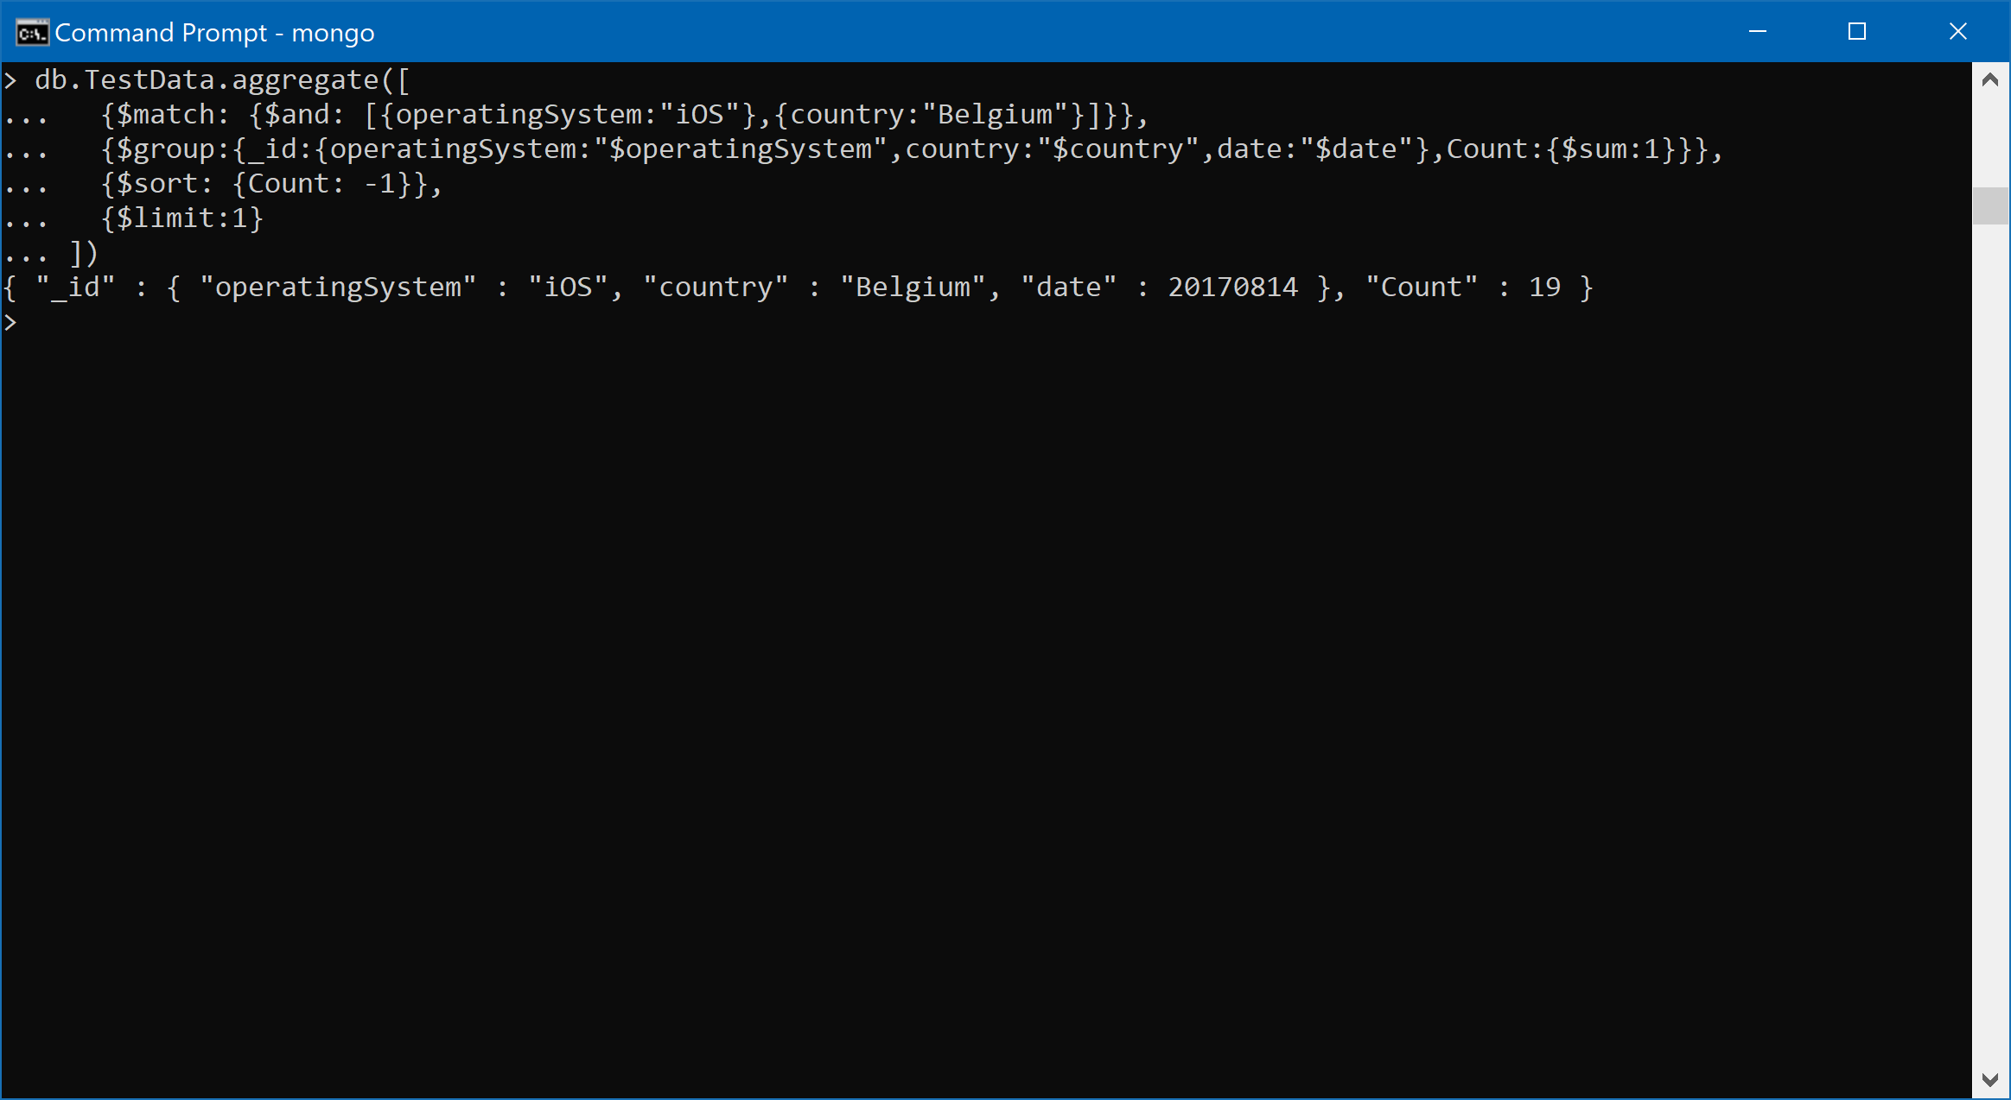

4. Were more mobile devices (than non-mobile devices) used to visit the store?

No SQL Query:

db.TestData.aggregate([

{$group:{_id:{ismobile:"$isMobile"},Count:{$sum:1}}},

{$sort: {Count: -1}}

])

Screenshot:

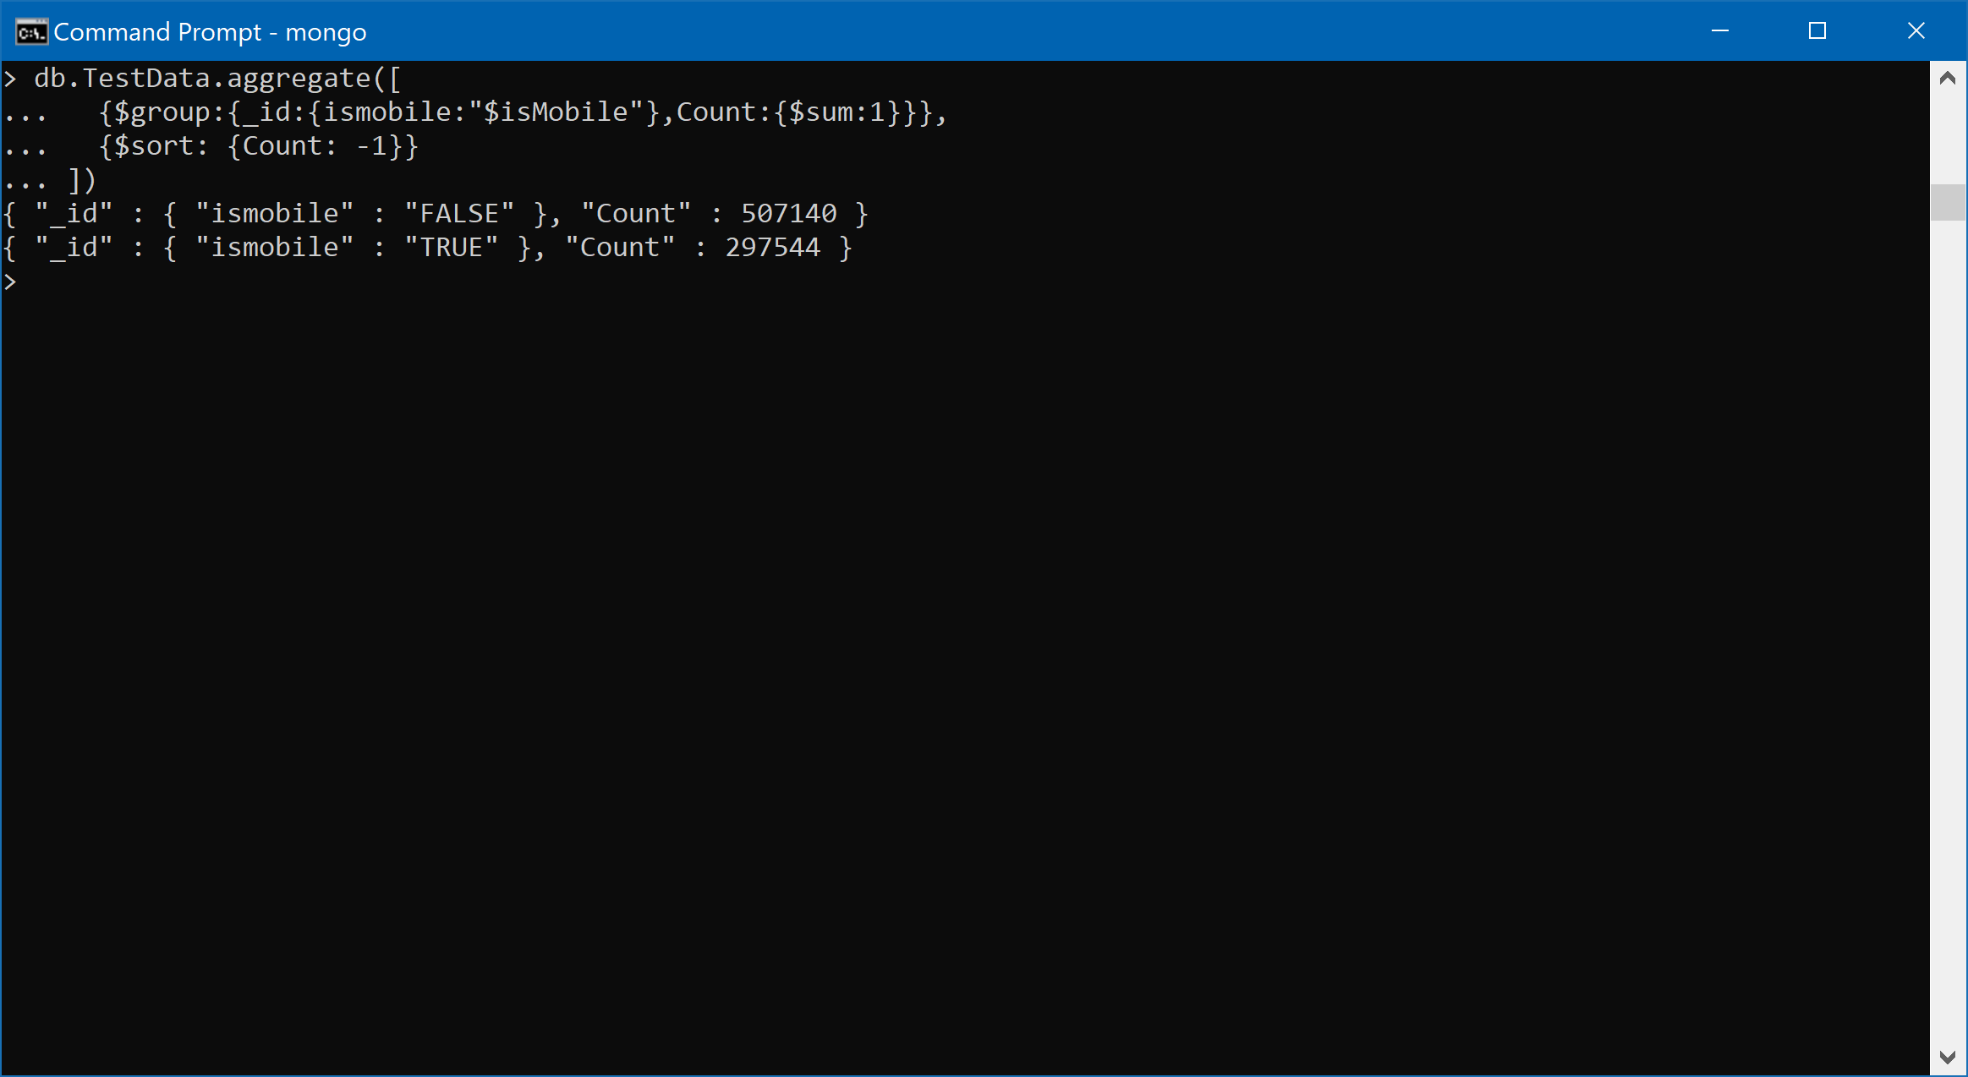

5. Provide a breakdown of store pageviews by city

No SQL:

db.TestData.aggregate([

{$match:{city:{$nin:["not available in demo dataset","(not set)"]}}},

{$group:{_id:{city:"$city"},pageviewcount:{$sum:"$pageviews"}}},

{$sort: {pageviewcount: -1}},

])

Screenshot:

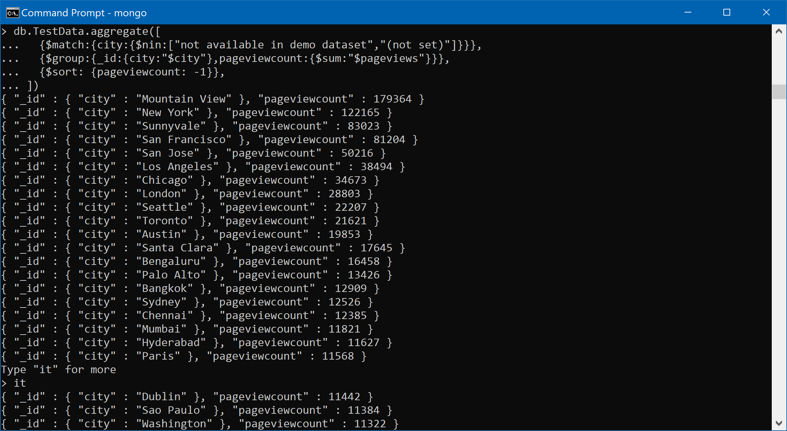

6. How many users used only Windows devices to visit the store?

No SQL:

db.TestData.aggregate([

{$match:{operatingSystem:"Windows"}},

{$group:{_id:{operatingSystem:"$operatingSystem"},Count:{$sum:1}}}

])

Screenshot:

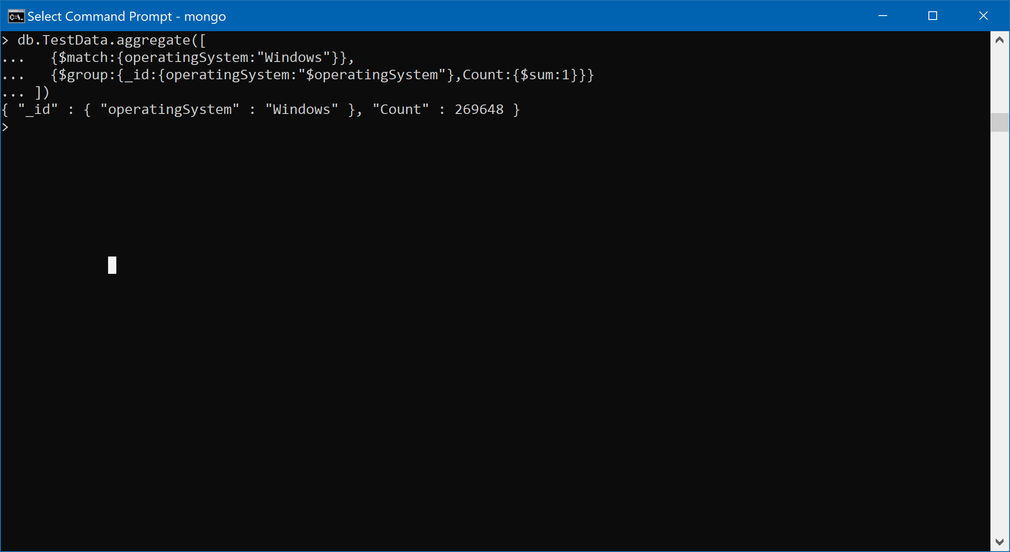

7. How many visitors had zero pageviews? (Write this at the Last)

No SQL:

db.TestData.aggregate([

{$match:{pageviews:0}},

{$group:{_id:{visitId:"$visitId",pageviews:"$pageviews"},Count:{$sum:1}}},

{$sort: {Count: 1}},

{$out:"SampleOut"}

],

{allowDiskUse:true})

db.SampleOut.find().count()

Screenshot:

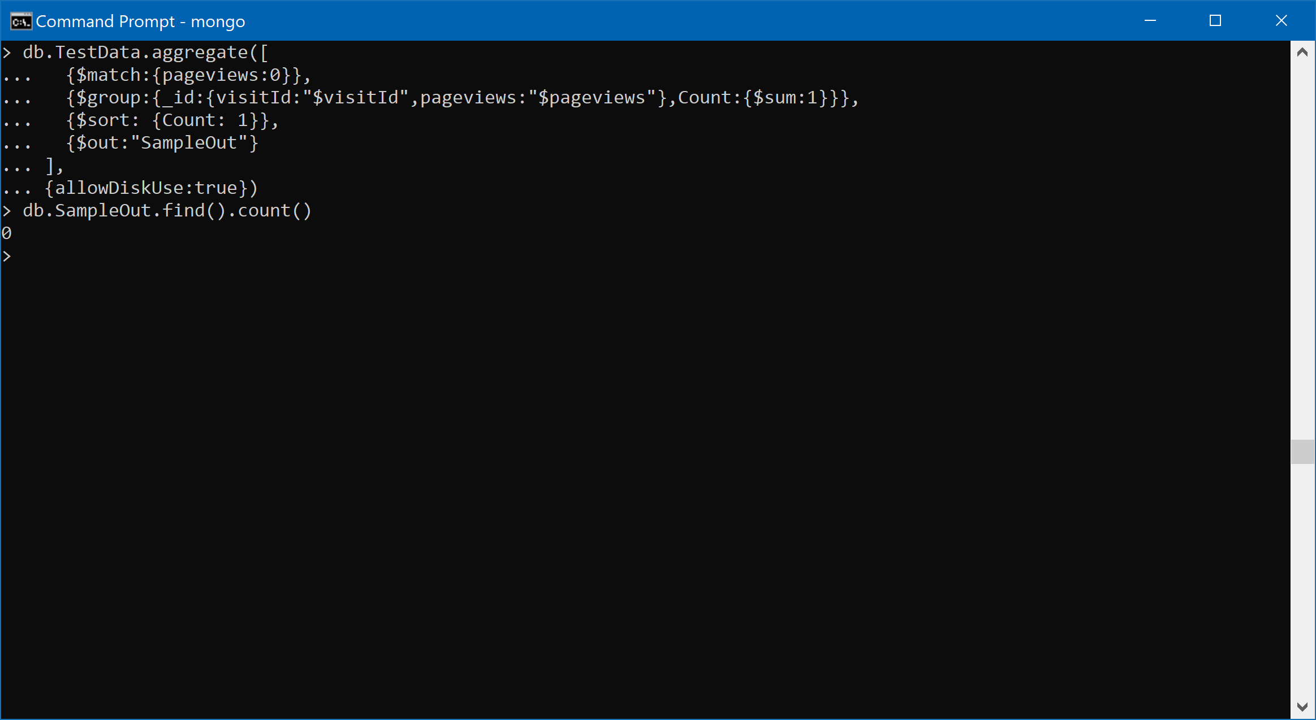

8.Which city (other than unknown) had the most number of desktop users?

No SQL Query:

db.TestData.aggregate([

{$match: {$and: [{city:{$nin:["not available in demo dataset","(not set)"]}},{deviceCategory:"desktop"}]}},

{$group:{_id:{deviceCategory:"$deviceCategory",city:"$city"},Count:{$sum:1}}},

{$sort: {Count: -1}},

{$limit:1}

])

Screenshot:

